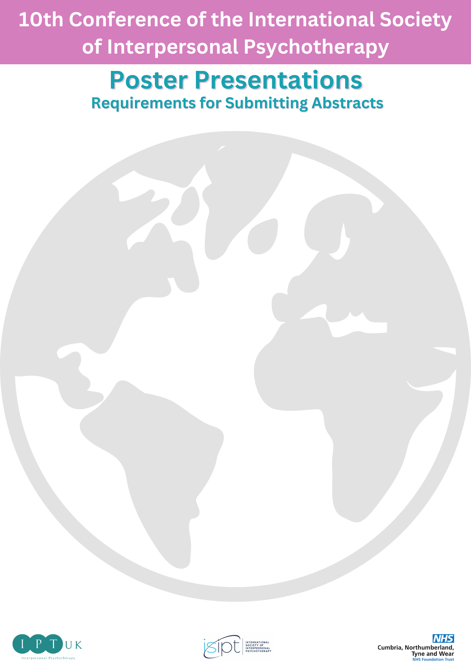

The Scientific Programme Committee of the ISIPT Conference invites you to submit Poster presentations. The Programme Committee will review all submitted abstracts. All accepted abstracts will be published.
Please note: Presenters of accepted abstracts must pre-register for the Conference by the deadline, 15th January 2024. Click here for tickets.
Abstracts must be submitted USING THE TEMPLATE BELOW via EMAIL to Fiona.rose@iptuk.net

IMPORTANT REQUIREMENTS
- Abstracts may be submitted for poster presentation.
- There is no limit to the number of abstracts an author may submit.
- Abstracts must be original and must not be or have been published or presented at any other meeting before the Congress.
- Abstracts must be submitted in English.
- All accepted abstracts will be published in the official Conference publications.
- Each presenting author is responsible for his/her registration fee(s) as well as travel and accommodation costs.
- Presenters who are unable to attend the conference should arrange for another individual to present.
- Abstracts must be submitted by the 30th November 2023. Abstracts received after this date will not be considered.
- The presenting author is required to ensure that all co-authors are aware of the content of the abstract before submission of the abstract.
- Abstracts are stating “data will be discussed in the presentation” will NOT be accepted.

POSTER AND ORAL PRESENTATIONS
- Presenting/corresponding author’s contact details (name, professional title, affiliation, email address)
- Please enter all authors in the order they should appear in the heading of the abstract. Presenting author should be chosen and marked.
  - Enter institutional affiliations of all authors.
  - Authors’ names must be in upper and lower case (J.J.C. Smith)
  - Affiliation details: department, institution / hospital, city, country
- Keywords: You may enter up to 10 keywords that define your abstract. The keywords must be in English and can include numbers.
- Abstract title: Limited to 25 words in UPPER CASE
- Abstract text: Limited to 250 words
- Abstracts should clearly state:
  - Objectives
  - Methods
  - Results
  - Conclusions
- Abbreviations may be used if standard or if spelled out and defined at the first use (put in parentheses immediately after the first mention of a term or phrase). Compounds should be mentioned with the generic name, in lower cases. Commercial names are admitted in the text, with an ®, and if in brackets following the generic name, i.e. “generic (Commercial ®)”.
- Abstract Topic: Abstracts must be allocated to a specific category for the Scientific Program.

